RUSSIAN RIVER ROACH

Lavinia symmetricus ssp.

Status: Class 3. Watch List. Although apparently in no danger of extinction, populations could decline rapidly and disappear in many areas as the result of alterations to streams, changes in climate and water withdrawal for urbanization, rural residential development and viticulture. Additionally, there exists the possibility that the Russian River contains small distinctive populations that may be lost before they can be formally described and provided the protection they deserve as distinct taxa.

Description: Russian River roach are a small (adult size typically 50-120 mm) bronzy cyprinid very similar to the Central California roach in most respects. However, they differ in having a trim, slender body, a somewhat pointed snout, a slender caudal peduncle and long fins. Russian River roach have a mean of 8.7 dorsal fin rays and 8.1 anal fin rays (Hopkirk 1973). Individuals rarely exceed 120 mm; the largest roach captured during spring surveys on Austin Creek in 2007 was 116 mm and weighed 20.5 g (Katz unpublished data). See the Central California roach account for a more in-depth description of roach morphology.

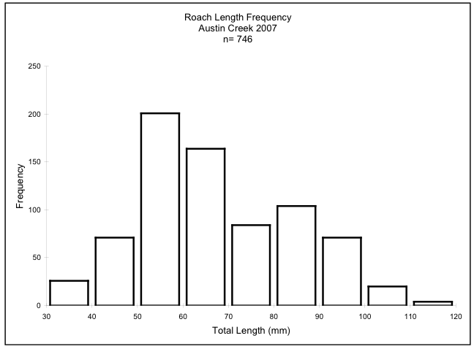
Figure 1. Frequency of length among roach greater than 30mm captured in the Austin Creek Feb 15- June 15, 2007. J. Katz, unpublished data.

Taxonomic Relationships: Russian River roach were first collected by Snyder (1908c, p. 175) who recognized them as Rutilus symmetricus and found them to be “alike in all respects” to R. symmetricus from the Napa River and to “agree closely with representatives from the streams tributary to San Francisco Bay.” In 1913, Snyder revised the systematics of roach, describing six species and erecting a new genus, Hesperoleucus, to house them. True to his initial assessment, Snyder placed Russian River roach into the species H. venustus along with roach from the streams entering San Pablo, Suisun, and San Francisco Bays. In a footnote from a paper on hybridization between hitch (Lavinia exilcauda) and roach in the Monterey basin, Miller (1945) suggested that Snyder’s roach species should be treated as geographic subspecies. In an unpublished M.S. thesis, Murphy (1948) agreed with Miller and concluded that all coastal species roach should be reduced to subspecific status of H. symmetricus. Although critical of Murphy’s reasoning, Hopkirk (1974) agreed with the diagnosis of placing all roach with in one species. He reached different conclusions, however, as to which roach populations belonged to which subspecies. Of particular importance to this account is that Hopkirk (1974) asserted that roach from the Russian River were more closely related to those from the Navarro River than they were to populations from the San Francisco Bay region. Roach from the Russian River are presumed to be the parent stock of roach in the Gualala and Navarro Rivers to which they where likely transferred by headwater stream capture.
Based on the morphological evidence (Hopkirk 1974), Moyle et al. (1995) moved Russian River roach into L. s. navarroensis. However, mitochondrial DNA (mtDNA) analysis (Jones 2001) found that roach from the Russian River were more closely related to roach from Clear Lake than they were to those from the Navarro River, leading Moyle (2002) to propose the Russian River-Clear Lake roach as a new subspecies. The most recent genetic analysis (Aguilar and Jones 2009) used both mtDNA and nuclear DNA microsatellites (nDNA). The mtDNA analysis found that a number of mtDNA haplotypes were shared by fish from the Russian River and Clear Lake, adding support to their grouping as a common lineage. It should be noted that there is considerable confusion regarding the interpretation of genetic information in the roach/ hitch species complex (Avise 1975, Avise and Ayala 1976, Jones 2001, Aguilar and Jones 2001). The microsatellite analysis provides the greatest resolution and suggests that roach from the two basins should be treated as separate taxonomic entities.
Murphy (1948c) noted that roach from Austin Creek, tributary to the Russian River, were the most morphologically divergent of all the roach populations he sampled from throughout California, including other collection sites from the Russian River watershed. Murphy (1948c, p. 36) speculated that the significantly fewer scales found on Austin Creek fish were either due to “chance” or “selective response to some localized environmental situation.” The distinctiveness of this population has never been verified, but Murphy’s morphometric evidence suggests that the Russian River, like the Central Valley, may contain genetically distinct roach populations endemic to tributary watersheds. If true, this finding would be highly unexpected because of the apparent lack of barriers to gene flow between sub-basins. No genetic study has yet been conducted that included roach from Austin Creek, and so the relationship of these roach to those in the Gualala River is not known, but the geographic proximity of the two basins and the distinctive nature of their respective roach populations would seem to invite investigation.

Life History: Russian River roach presumably share much of their life history with the Central California roach; therefore only life-history characters distinctive to Russian Roach river roach are covered here. For more in-depth coverage see the Central California roach account.
Roach commonly occur in the mainstem Russian River but account for only a small percentage of the fish assemblage in the middle and lower reaches of the river (Pintler and Johnson 1958, Chase et al.2001-2005, Cook et al. 2005). Roach are less common in the lower sections of the main river where their downstream limit appears to be the upper portions of the estuary near Duncans Mills. However, Goodwin et al. (1993) found that roach and western mosquitofish (Gambusia affinis) tended to move down into the main body of the estuary and the Willow Creek marsh during the summer and return to upstream habitats in the fall. In beach seine surveys, Cook et al. (2003-2007) found the fish assemblage at the confluence of Austin Creek to be dominated by steelhead, tule perch and roach, in that order of abundance. Pintler and Johnson (1958) recorded roach as only being common in the mainstem in areas around the mouths of tributaries. Hopkirk et al. (1980) found roach to constitute a minor part of the large schools of juvenile cyprinids and Sacramento suckers (Catostomus occidentalis) which he observed to be numerous in the shallow side-channels of the mainstem in spring.
In Russian river tributaries roach are the dominant taxa, accounting for between 45% and 60% (average 54%) of numeric fish abundance (Pintler and Johnson 1958). In-channel recreational impoundments in tributary streams, or “summer dams,” were once very common in the Russian River basin but have been mostly banned because of their negative impact on salmonid habitat. Roach and Sacramento suckers tended to be the primary fishes which utilized summer dam habitat (Cox 1984).
Russian River roach spawn in spring and early summer, after water temperatures exceed 16°C, although spawning activity has been observed well into July (Moyle 2002).
Feeding habitats are presumably similar to other populations of California roach although in Austin Creek, a tributary to the Russian River, Sonoma County, roach were observed taking mayflies at the surface much like rising trout (Katz, unpublished observations).

Habitat Requirements: Roach are found in a wide variety of habitats in the Russian River, including the main river wherever there is deep cover (e.g. fallen trees) to protect them from predators. Price and Geary (1978, 1979) found that they were frequently the dominant fish in small (0.025-0.10 m²/sec summer flows) tributary streams, where the water is clear, well oxygenated, with dominant substrates of cobble and boulder, and depth shallow (average 10-50 cm) with pools up to 1 m deep. Temperatures in such streams rarely exceed 25°C because they tend to be well shaded.

Distribution: Russian River roach are restricted to the Russian River and its tributaries.
They are among the dominant species in the middle sections of many tributary creeks including Mark West, and Santa Rosa Creeks (Chase et al. 2005,), Maacama Creek (Merrit Smith Consulting 1995, 2003), Austin Creek (Katz et al. 2006. 2007) and Big Sulphur and Pieta Creeks (Price and Geary 1978, 1979). Roach collected in Austin Creek were found to be morphologically distinct when compared to populations from throughout Central California (Murphy 1948c). It is quite possible that roach populations in the Eel River, regarded as introduced, are derived from Russian River roach because of their proximity to one another. This needs be confirmed with genetic studies.

Trends in Abundance: There is little indication that Russian River roach are less abundant than in the past, but few surveys exist. It is likely that they were once common in the main river, prior to the introduction of smallmouth bass and other alien predators, but there is no real evidence for this one way or another.

Nature and Degree of Threats: While Russian River roach are very resilient fish, they tend to disappear from streams that are (1) dewatered by diversions and pumping for residences, vineyards, pasture and other uses, (2) heavily altered by channelization which simplifies habitat, and (3) invaded by alien predators such as green sunfish (Lepomis cyanellus) (Table 1). In the Russian River basin the high rate of conversion of forestland to vineyards is likely the largest threat facing the stream fishes. Following decades of clearing lowland areas for orchards and other agriculture, vineyards have rapidly expanded onto hillsides over the last 20 years. Forestland conversion to viticulture and hillslope vineyards in particular, directly impact stream flow in small streams. Deitch et al. (2009a,b) showed that vineyard water use for irrigation and frost protection is significantly affecting in-stream flow in the Russian River tributaries in Sonoma County. However, alteration to basin hydrology resultant from new vineyards is of equal concern. For more details on problems in the Russian River basin, see the Russian River tule perch account and for broad problems affecting roach populations in general, see the Central California roach account.

 | Rating | Explanation
Major dams | Intermediate | Dams control flows in the Russian River, resulting in decreased variability in flows, increased summer flows, and changes in water quality
Agriculture | High | Water withdrawal increases as vineyards increase and demand water for irrigation and frost protection
Grazing | Intermediate | Heavy grazing can lead to stream incision, loss of riparian vegetation, and to streams drying more quickly and completely.
Rural Residential | High | Residential water withdrawal is a serious cause of decreased summer flow in small streams throughout the watershed.
Urbanization | Intermediate | Increasing growth of Santa Rosa and surrounding communities contributes to pollution and altered aquatic habitat
Instream mining | Intermediate | Gravel mining in the main river simplifies habitat and increases turbidity
Mining | Low | Mainly legacy affects from past mining
Transportation | Intermediate | Much of the river and tributaries are bordered by roads, resulting in siltation, channelization, and habitat loss.
Estuarine alteration | N/A
Logging | Low | Legacy effects may still exist but logging in the Russian River watershed is much reduced
Fire | Intermediate | Fire may cause local extirpation more frequently than historically was the case
Recreation | Low | Recreational use of the river is heavy but results in little direct threat, except when trees in the water are removed.
Harvest | N/A
Hatcheries | N/A
Alien species | High | Intolerant of introduced predatory fish, especially centrarchids such as smallmouth bass
Table 1. Major anthropogenic factors limiting, or potentially limiting, viability of populations of Russian River roach in California, where a factor rated “high” is a major limiting factor, a factor rated “intermediate” is a factor that has the potential to be a major limiting factor but has had only a moderate effect so far on population viability, and a factor rated “low” has a low or unknown effect on population viability. Certainty of these judgments is 2.

Effects of Climate Change: Russian River roach are well adapted to the warm, arid conditions of the California’s Mediterranean summers, their frequent dependence on intermittent pools suggests that they are also particularly susceptible to increasing aridity associated with climate change. Roach are one of the few native fish that are able to endure life in isolated summer pools in intermittent streams where temperatures soar, dissolved oxygen levels plummet and most other fish die. John O. Snyder (1905) observed roach were able to persist when “nothing remains of the stream but a few small disconnected pools.” While such tenacity bodes well for roach in a future of dwindling in-stream water supplies, it also suggests that they are likely to be extirpated from streams which now maintain “isolated disconnected pools” but which may soon dry completely under the dual strains of less rain and increased human water use, including surface and ground water withdrawal for vineyard expansion and rural residential development.

Status Determination. Score = 3. Russian River roach do not seem to be in any immediate danger of extinction although gradual loss of tributary populations combined with changes to the river itself which eliminates connectivity among tributaries, could pose problems. The Russian River roach is listed as “G5T2T3, Imperiled” by NatureServe where it is included in a taxon described as the Clear Lake-Russian River roach subspecies.

Metric | Score | Justification
Area occupied | 1 | Confined to the Russian River and its tributaries
Effective population size | 5 | Population(s) large and numerous
Intervention dependence | 3 | Phylogenetic analysis needed
Tolerance | 4 | Remarkably resilient fish
Genetic risk | 3 | Little threat to genetic integrity if assumed to be a single taxon. However, if polytypic distinct subpopulations may face some genetic threat from introgression.
Climate change | 3 | Complete drying of isolated pools in intermittent streams is likely to extirpate roach from stream reaches or even entire tributary watersheds
Limiting factors analysis | 4 | See Table 1.
Average | 3.3 | 23/7
Certainty (1-4) | 2 | Little published information
Table 2. Metrics for determining the status of Russian River Roach, where 1 is a major negative factor contributing to status, 5 is a factor with no or positive effects on status, and 2-4 are intermediate values. See Introduction for further explanation.

Management Recommendations: A thorough survey of all Russian River tributaries is needed to determine extent of Russian River roach distribution, distinctiveness and status of populations. In particular, streams with past surveys should be resurveyed for changes in status. Some streams that are in good condition and seem to have few threats to them at the present time should be selected as refuges for native fishes and amphibians and managed accordingly. Opperman and Merenlender (2004) studied Russian River tributaries and provide management recommendations for them, including maintaining live trees (live wood debris) on the banks and in the channels to create pool habitat that roach prefer. In addition, Merenlender et al. 2008 developed GPS-based water resource analysis tools which seek to quantify and balance water needs and water resources on a watershed scale. The tools were created to aid in sustaining instream ﬂow while simultaneously enhancing water security for local landowners and vineyard operators. The tools can be used to evaluate various water-policy scenarios, estimate the cumulative effects of water extraction methods on the natural hydrograph across a large spatial scale (including temporal variation), and provide information for the watershed-level planning required to recover environmental flows. Such tools would be of great value, especially in wine country where water resources are increasingly over utilized.

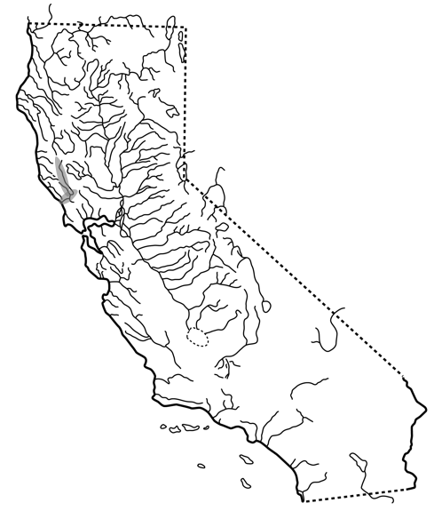

FIGURE 23. Distribution of the Russian River roach, Lavinia symmetricus ssp., in California.

